UNIVERSITY OF AGRICULTURAL SCIENCES
BANGALORE, 560065

PROJECT REPORT
EAI-421: Application of AI & ML in Agriculture (0+10)

Project Title: Farm Mechanization in India: Status and Way Forward

Submitted Submitted by
The Course Teacher, Harshitha H V (BMB2022)
AI and ML in Agriculture, Sahana (BMB2047)
CoA, UASB, GKVK Tejashwini S J (BMB2055)

Report on Farm Mechanization in India: Status and Way Forward

Abstract
India has witnessed significant progress in farm mechanization over the past five decades. Farm power availability has shifted from animate sources (human and draught animals) to mechanical and electrical sources, with tractors emerging as the dominant contributor. Mechanization has improved cropping intensity, productivity, and reduced drudgery, but disparities remain across states, particularly in the northeast. This study assesses farm power dynamics, mechanization levels across crops, and their impact on agricultural productivity, while suggesting pathways for future advancement.

Introduction
Agriculture remains a cornerstone of India’s economy, contributing 20.2% to GDP and supporting nearly 18% of the world’s population on just 2.5% of global land area. Despite record food-grain production, small and fragmented landholdings limit mechanization. Mechanization plays a pivotal role in enhancing productivity, reducing labour intensity, and ensuring timely operations. However, India’s mechanization level (47% in 2021-22) lags behind developed nations, highlighting untapped potential.

Review of Literature
1. Mehta et al. (2014) - emphasized mechanization as a catalyst for productivity and diversification.
2. Tiwari et al. (2019) - highlighted challenges of fragmented holdings and low mechanization in hilly regions.
3. Anonymous (2020b) - documented adoption of implements for seedbed preparation, sowing, irrigation, and harvesting.
4. Chand & Singh (2022) - analysed workforce dynamics, noting increased female participation in agriculture.

Objectives
1. To analyse trends in farm power availability in India.
2. To assess mechanization levels across major crops.
3. To evaluate the impact of mechanization on cropping intensity and productivity.
4. To identify regional disparities in mechanization.
5. To propose strategies for future mechanization growth.

Materials and Methods
Data Sources: Agricultural Statistics, Census reports, Tractor and Mechanization Association, Livestock Census, CIAE Data Book.
Parameters Studied: Farm power availability (kW/ha), cropping intensity, tractor density, mechanization levels by crop.
Methodology: Time-series analysis of farm power sources (1971–2022), state-wise categorization of farm power availability, and correlation with productivity.

System Architecture
The study framework includes:
1. Input Layer: Data from government reports and census.
2. Processing Layer: Calculation of farm power availability, CAGR, and mechanization levels.
3. Output Layer: Trends in mechanization, crop-wise mechanization levels, and regional disparities.
4. Visualization Layer: Graphical representation of farm power trends and mechanization impacts.

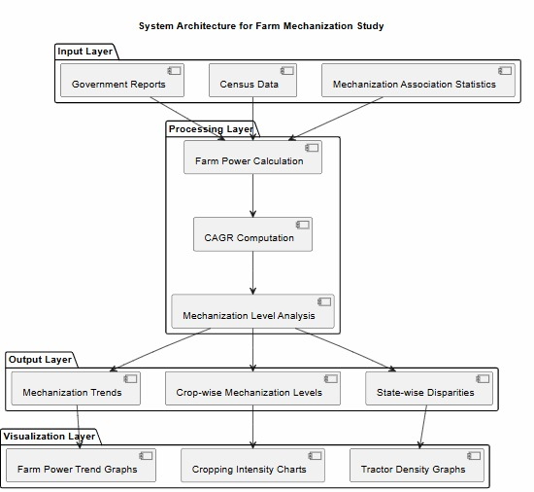

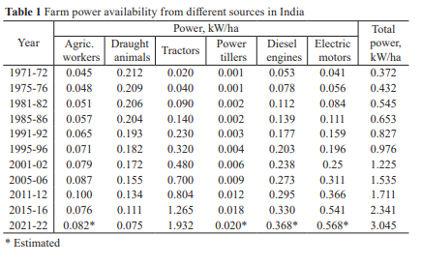
Experimental Results:
Farm power availability rose from 0.372 kW/ha in 1971-72 to 3.045 kW/ha in 2021-22.

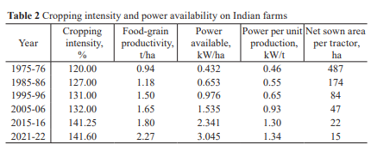
Cropping intensity increased from 120% (1975-76) to 141.6% (2021-22).
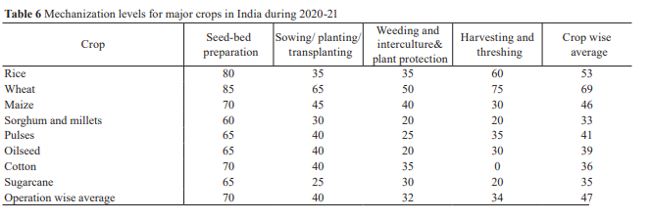
Mechanization levels: Wheat (69%), Rice (53%), Maize (46%), Pulses (41%), Oilseeds (39%), Cotton (36%), Sugarcane (35%), Millets (33%).

Result Discussion
Mechanization has clearly enhanced productivity and cropping intensity. However, uneven adoption across states reflects socio-economic and geographic constraints. Tractor density strongly correlates with food-grain productivity, yet hilly terrains and small holdings hinder mechanization in northeastern states. Custom hiring centres have emerged as a solution for small farmers.

Data Visualization (Matplotlib)
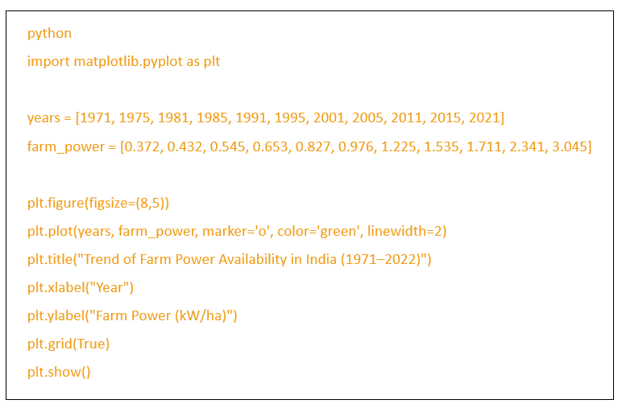
Here’s a visualization of farm power availability trends (1971–2022):

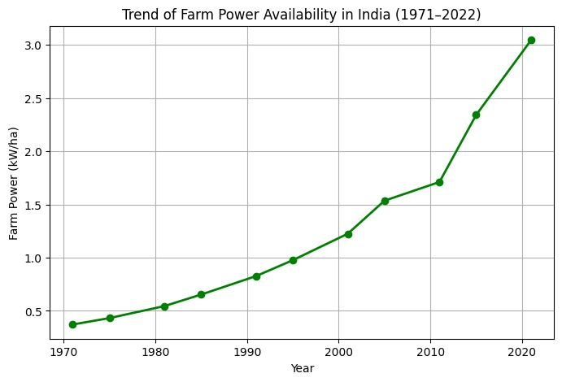
This chart shows the steady rise in farm power availability, reflecting mechanization growth.

Summary and Conclusion
Farm mechanization in India has advanced significantly, with tractors and electric motors replacing traditional animate power. Mechanization has improved productivity, cropping intensity, and reduced drudgery. However, disparities across states and crops remain. Small holdings, hilly terrains, and limited access to machinery hinder uniform adoption.

Future Scope
1. Promote Custom Hiring Centres to support small farmers.
2. Introduce lightweight machinery for hilly terrains.
3. Expand micro-irrigation systems to optimize water use.
4. Encourage precision farming technologies (GPS-guided tractors, drones).
5. Policy support for equitable mechanization across states.

References
- Mehta, C.R., et al. (2014). Agricultural Mechanization in India.
- Tiwari, et al. (2019). Farm Land Fragmentation and Mechanization Challenges.
- Anonymous (2020b). Agricultural Statistics at a Glance.
- Chand, R., & Singh, S. (2022). *Workforce Participation in Indian Agriculture.
- CIAE Data Book (2021). Farm Power Statistics.

THANK YOU…

